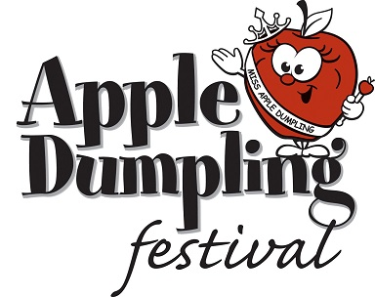

Are you looking for a unique way to promote your business where you can:

Come face to face with thousands of potential customers.

Display your product or service for potential customers to see.

Handout samples or small gifts to potential customers.

Hand out literature to potential customers.

Display a race car or unique company vehicle.

Have a company mascot meet and greet.

Have your name and logo associated with a strong local event

Have your name and logo appear in newspaper and radio ads.
Have your logo appear center stage at the event

Well here is your chance to promote your business while supporting a 68 year old community event – The Apple Dumpling Festival and Pageant!

For the past 68 years, local area businesses have supported the Festival while promoting their business by purchasing a sponsorship package and/or renting a space on the midway. As a festival sponsor, your business will have the unique opportunity to come in contact with 8,000 to 10,000 people. As well as benefiting from the promotions associated with this one-of-a-kind community celebration.

The festival and pageant are a tradition for our community.
The festival will feature an expanded midway with amusement ride company, Bartlebaugh Amusements, more food vendors, games, entertainment, and of course Apple Dumplings! The event will be for 3 days, Thursday May 8th to Saturday May 10th . The pageant will include three categories of girls 4-7, 8-12 and 13-17. It will be held at Willow Glen Park in Sinking Spring and will have plenty of parking!

This is a marketing program for your company not a donation.
This is to be considered an advertising opportunity, not unlike the programs offered by the Reading Phillies. This is not a donation and therefore is 100% deductible. This event has been a part of our lives for many years and the pageant helps young women learn skills that will help them for the rest of their lives. We hope you decide to help continue this local community event by considering one of the following sponsorship packages.

Sponsorship Packages

Red Delicious: $1000
- Company Night featuring PA announcements.
- Logo and link on web site (22,000 visits)
- 3’x4’ space for your banner displayed center stage for all three nights.
- 10x10 Booth space on midway
- 4 Facebook posts on our page with your logo and link

Macintosh: $500
- PA announcements
- 2’x4’ space for your banner displayed center stage for all three nights.
- 10x10 Booth space on midway
- Facebook post on our page with your logo and link

Booth Space: $300
- 10x10 Booth space on midway.

Apple Dumpling Sponsorship Program

Please check the appropriate program below, fill out the form, and send a check to Konopelski Festivals LLC 94 Park Avenue Sinking Spring, PA 19608. Make check payable to “Konopelski Festivals LLC”. If you have any questions or would like to discuss how you can use the Apple Dumpling Festival to promote your business, please contact Heather at 610-777-6388 or via email at: heather@konopelski.com

____Red Delicious $1000

____Macintosh $500

____Booth Space $300

Red Delicious, and Macintosh levels include the option of a booth space. Please indicate here if you will be setting up a booth. Please note tables, chairs, and tents are not provided. If you need assistance with any of these item’s, please contact Knights Rental at 610-750-6178

_____Booth Space needed
_____Booth Space not needed

Company Name:_____________________________________________________

Contact Name:_______________________________________________________

Address:____________________________________________________________

Phone:____________________________ Fax:_____________________________

Email:____________________________

